Title:
Can Your Sponge or Loofah Make You Sick?
Keywords:
sponge hygiene, loofah bacteria, skin infections, bathing tools, Nigerian skincare, loofah risks, fungal infections, sponge safety, clean skin habits
Short Description:
Your sponge or loofah could be harming your skin more than helping it. Here's what every woman should know about using them safely.

Can Your Sponge or Loofah Make You Sick?
You step into the bathroom, grab your sponge or loofah, and scrub your body clean. It's part of your daily routine.
But what if I told you that same sponge could be the reason behind your skin rashes, itching, stubborn pimples or even infections?
Yes, the same thing you use to stay clean can actually make you sick, especially if you're not using it the right way or keeping it clean.
Let me show you how this affects you.

Why Sponges and Loofahs Can Be Risky
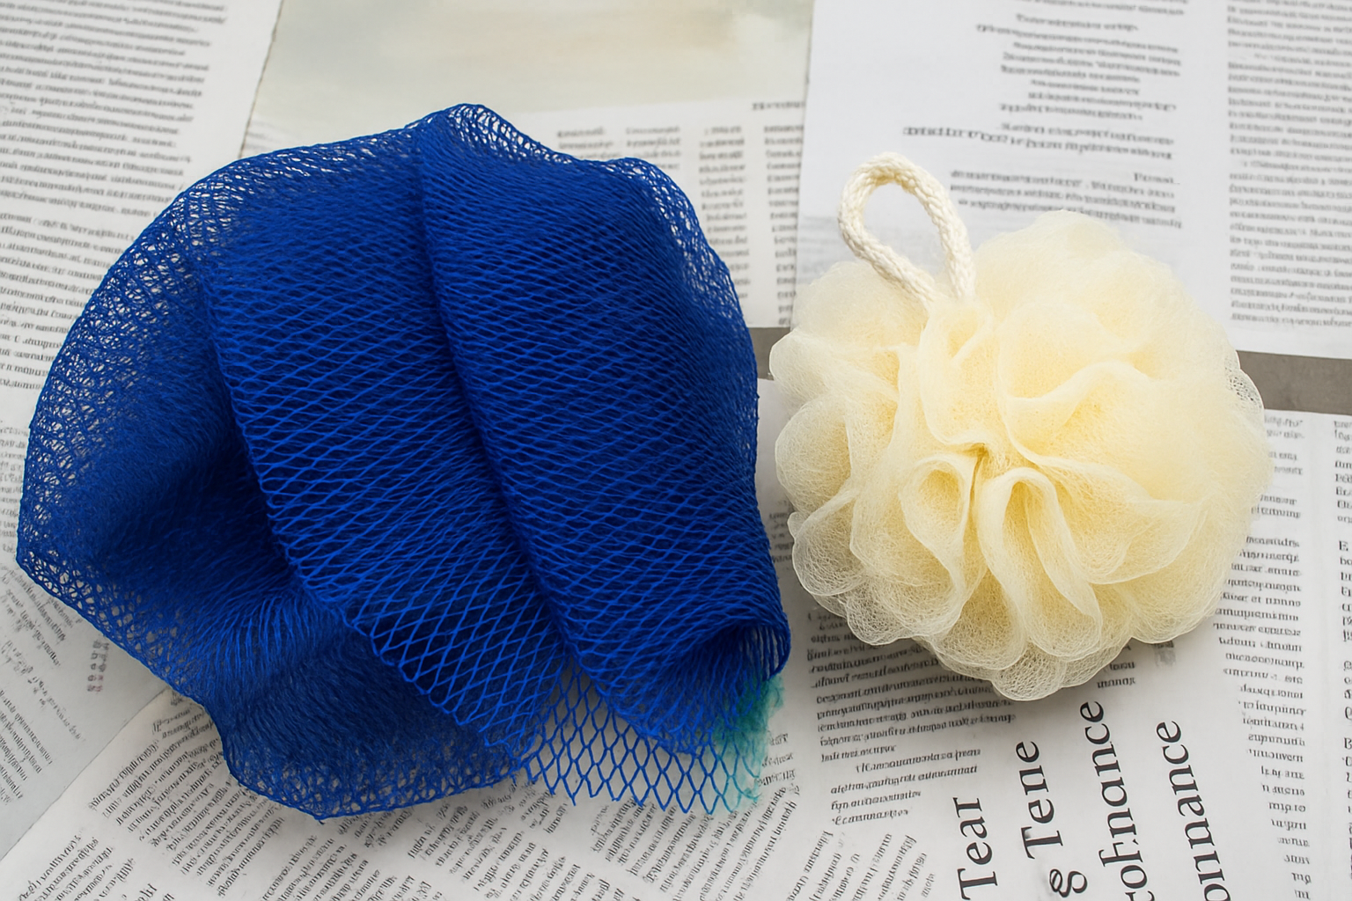
Your traditional Nigerian bathing sponge (net sponge or "sapalọ" sponge) or loofah might look clean, but underneath, it can be a perfect hiding place for germs.
Here's why:
- They stay wet for hours after your bath, and bacteria love moisture.
- They collect dead skin cells, body oils, sweat, and dirt while you bathe. That mixture becomes food for germs.
- Most people don't rinse or dry them properly, so the bacteria just keep growing.
- If you hang it inside the bathroom, the damp, humid air makes it worse. Research shows that moist, warm environments (like bathrooms) help bacteria and fungi grow fast on personal hygiene items like loofahs and body sponges.
Some of the common germs found on dirty sponges include:
- Staphylococcus aureus: Linked to skin infections and boils
- Pseudomonas aeruginosa: A common sponge-dwelling bacterium that thrives in moisture, can worsen body odour, and cause rashes or skin infections.
- Candida: A fungus that may cause itching and yeast infections in body folds
- Even mould, if it's never dried out properly
All of these can end up on your skin when you reuse the sponge.
How This Can Affect Your Skin
Using a dirty sponge or loofah isn't just gross; it can cause skin problems. These are some of the common issues:
- Breakouts: You may notice more pimples on your back, chest, or bum, especially if your sponge is spreading bacteria instead of cleaning them off.
- Itching or Rashes: If fungi like Candida are growing on your sponge, you could develop itchy patches, especially under your breasts, inner thighs, or between your butt cheeks.
- Worsened Skin Conditions: For people with eczema or sensitive skin, dirty sponges can trigger flare-ups, redness, or irritation.
- Infections: Shaving bumps or small cuts can get infected if your sponge carries germs like Staphylococcus aureus.
- Body Odour or Rashes: If your sponge smells bad or feels slimy, it's likely full of bacteria. Using it will only transfer that smell and irritation to your body.
- Boils and Folliculitis: Reusing a dirty sponge can clog your pores and cause painful boils or inflamed hair follicles.
Signs Your Sponge Is Unsafe to Use
- It smells weird: A sour or musty smell means germs are already present.
- It feels slimy: That slippery feel isn't normal; it's a sign of bacteria or mould buildup.
- It's discoloured: If the colour is fading or has dark spots, dump it.
- You've used it for more than 3 to 4 weeks: Even if it looks fine, it's likely full of hidden germs.
- Your skin reacts after use: If you feel itchy, notice more pimples, or develop a rash after bathing, your sponge may be the culprit.
If any of these sound familiar, it's time to let that sponge go.
How to Use Sponges Safely
If you still prefer using a sponge or loofah, that's fine, just make sure you're using it the safe way:
- Rinse it well after every bath to remove soap, dirt, and dead skin.
- Squeeze out all the water before hanging it.
- Hang it in a well-ventilated area, not in a wet bathroom.
- Avoid using it on broken skin, cuts, or after shaving.
- Wash it regularly with hot water or disinfect it once a week.
- Replace it every 3 to 4 weeks, even if it appears to be fine.
- Please don't use it on your face or private areas. These are delicate zones.
- Never share your sponge, not even with your sibling or spouse.
Better Alternatives to Try
If you're tired of dealing with sponges that get dirty too fast, here are safer and more hygienic options you can consider:
- Silicone scrubbers: They don't hold water, so germs don't grow easily. Plus, they're extremely easy to clean and last longer.
- Exfoliating gloves: These are good for scrubbing, but make sure you wash and dry them properly after each use.
- Your hands and a soft towel: Sometimes, less is more. For sensitive or acne-prone skin, your hands can be cleaned with a mild soap without irritation.
Regardless of what you use, the key is to keep it clean and dry after every use.
Final Thoughts
Every woman's skincare journey is unique, but the simple act of bathing should never compromise your skin's health.
If you've ever experienced unexplained breakouts, itching, or bumps after bathing, it may be time to take a closer look at what you're using, not just the soap.
Have you ever had skin issues you think were caused by a sponge or loofah you used in the bath? Or found a method that works better for you?
I'd love to hear what your experience has been. Let's talk about it.

Researched by Victoria Odueso

